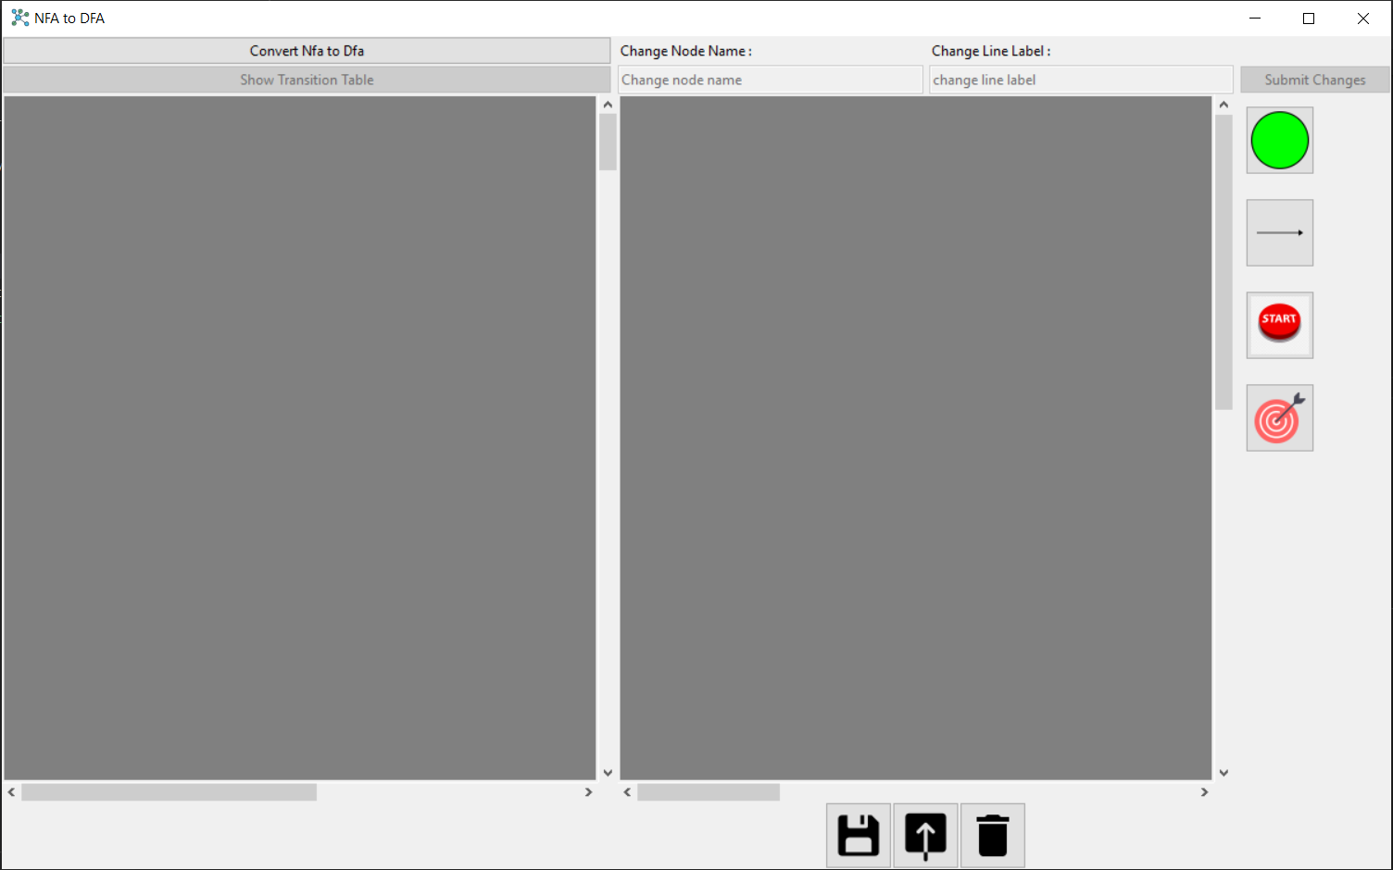**User Guide**

Figure : NFA2DFA Application

At first in order to use the Nfa2Dfa application which is shown in (fig.1) you have to make a graph (NFA) to be able to convert the NFA to DFA and view the transition table.

To build a graph (NFA) you will start by inserting the number of nodes that you prefer at the board in the right side by pressing on the green circle which represents the nodes (fig.2) then press at the board the number of times you prefer, as per every press you make at the board a node is inserted.

Figure : How to insert a node

Ex: Inserting 6 nodes (fig.3).

Figure : Inserting 6 nodes

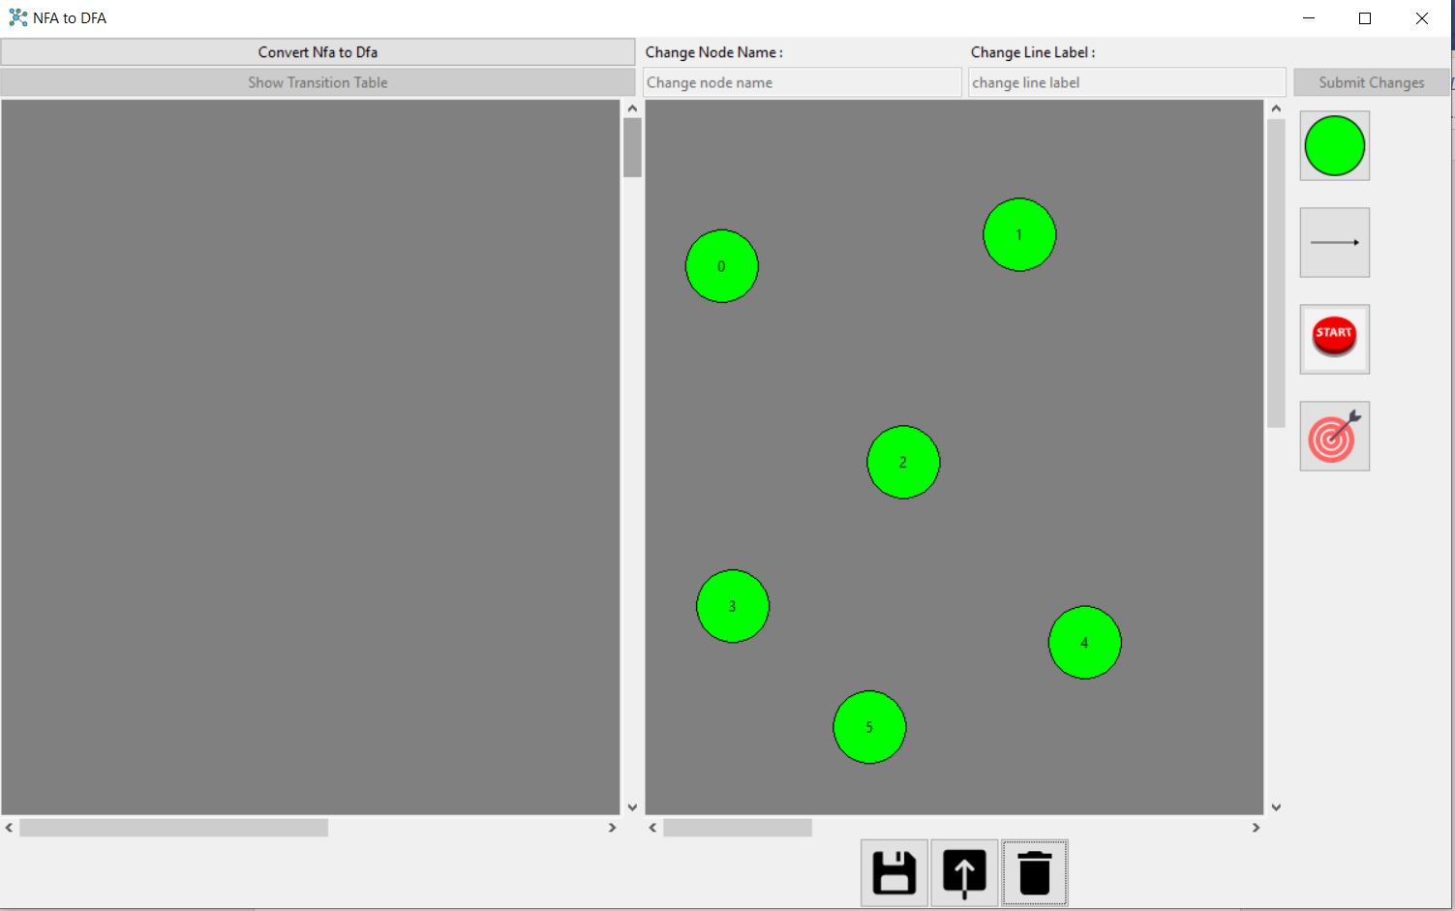

After inserting the nodes, you will have to connect these nodes to make the able to interact with each other to reach the goal you need.

To connect the nodes, you will have to press on the arrow at the right shown in (fig.4) then select the node which the arrow is going from then the node the arrow is going to.

Figure : How to connect nodes

Ex: Connecting nodes (fig.5).

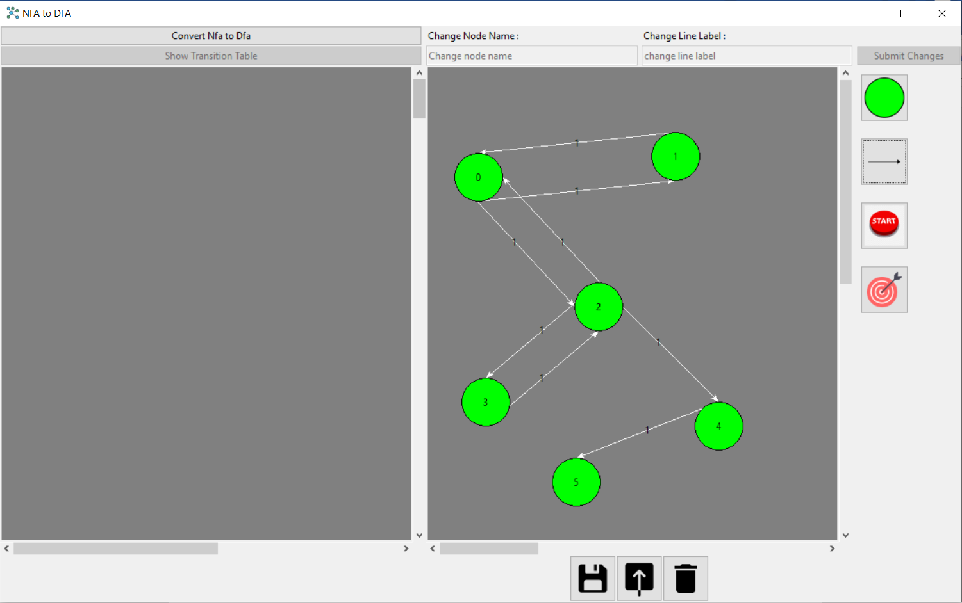

Figure : Connecting nodes

After inserting nodes and connecting them you will have to assign a node to start from (starting state) and a final states, you can assign more than one node as a final but only one as start , we will assign only one start and one goal to make it easy for you till you get used to it.

In order to assign a node to start from you will press on the button which contains the word start at the right shown in (fig.6) then select which node you want as a start.

To assign a node as the goal you will press at the last button on the right shown in (fig.6) then select which node you want as the goal.

Figure : How to assign start and goal nodes

Ex: Assigning (node 0) as the start which its color changed from green to white as it is the start and (node 5) as the final and its color also changed to red as it is the final (fig.7)

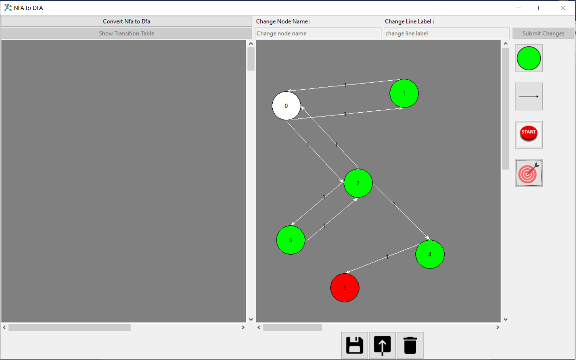

Figure : Assigning nodes

After building the graph and assigning the start and the goal nodes you can remove or edit any node or connecting line you need.

In order to remove any node or connecting line you will have to select this node or line by pressing on them then pressing delete or backspace from the keyboard.

To edit any node and by editing, I mean changing names of the nodes to do that you’ll select the node by pressing on it then start typing on the top left bar shown in (fig.8) to change its name then press enter or submit changes which is shown in (fig.8) as well.

To edit any connecting line which means changing its transition value you’ll select the line by pressing on it then you’ll start typing on the top right bar shown in (fig.8) the new transition value you want then then press enter or submit changes which is shown in (fig.8).

Figure : Editing nodes and lines

Ex: Removing (node 2) and its connecting line from the graph (fig.9).

Figure : Deleting nodes and lines

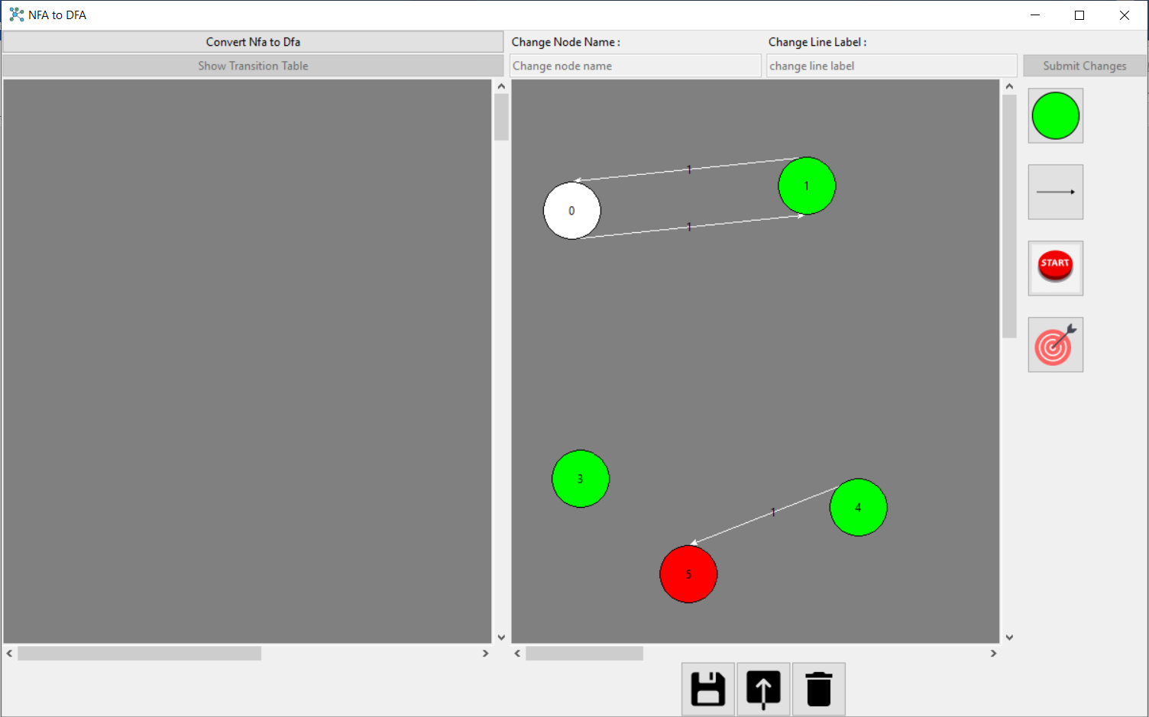

Ex: Changing name of (node 5) to “ZZ”, and changing the transition value to line (4 -> 5) to a (fig.10).

Figure : Editing nodes and lines

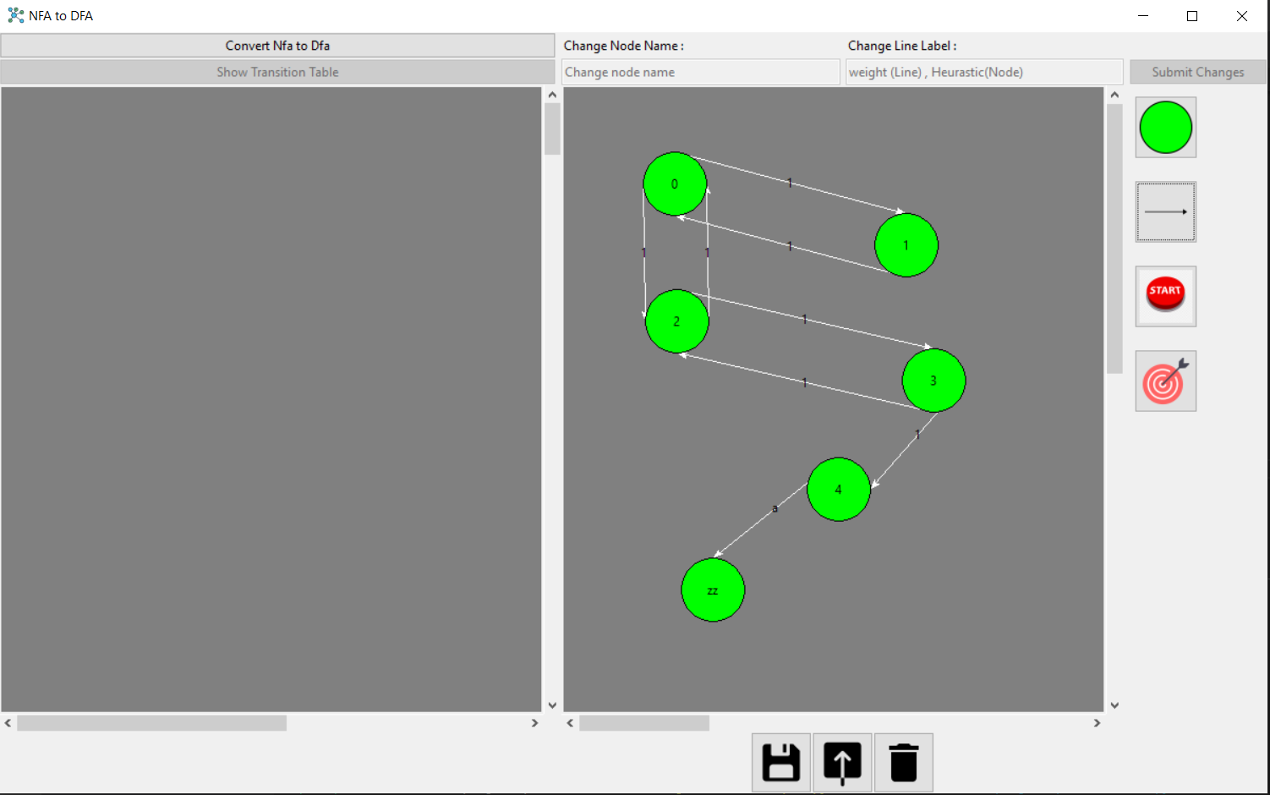

After building the graph and applying all the changes that you need on it you can save it or delete it, to save it you will press at the button at the bottom left shown in (fig.11), to delete it you will press at the button at the bottom right shown in (fig.11) as well.

Figure : Saving and Deleting Graph

Ex: In my case I saved the graph by the name “Sample” then I deleted it (fig.12).

Figure : Saving the graph then deleting it

In order to get the saved graph and start operating on it you’ll have to press on the button in the middle bottom between the saving and deleting buttons shown in (fig.13).

Figure : Showing saved graphs

Then select the saved graph you want to operate on from your previous graphs then press open as shown in (fig.14).

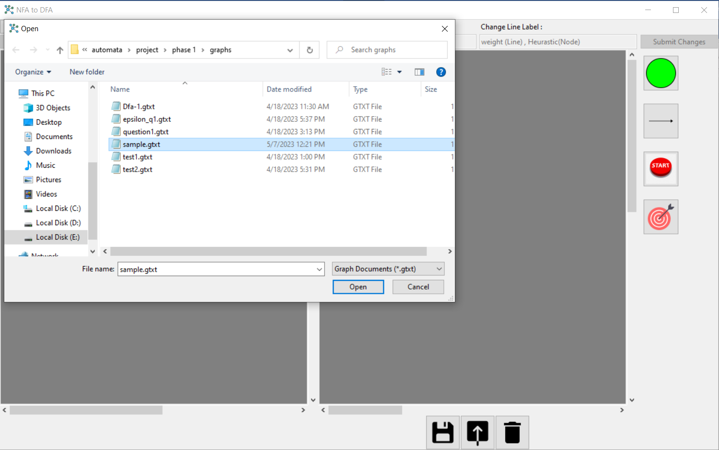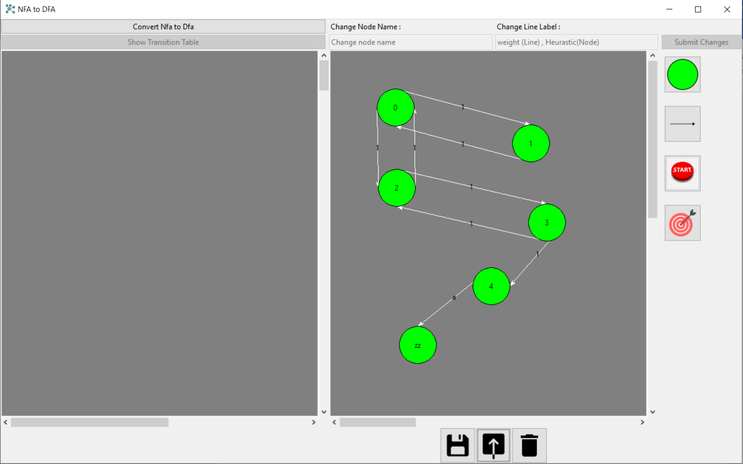

Figure : Opening a previously saved graph

The transition of each line is comma separated “,” means if you want to transfer from 0-1 by a and b then add transition value for the line a,b

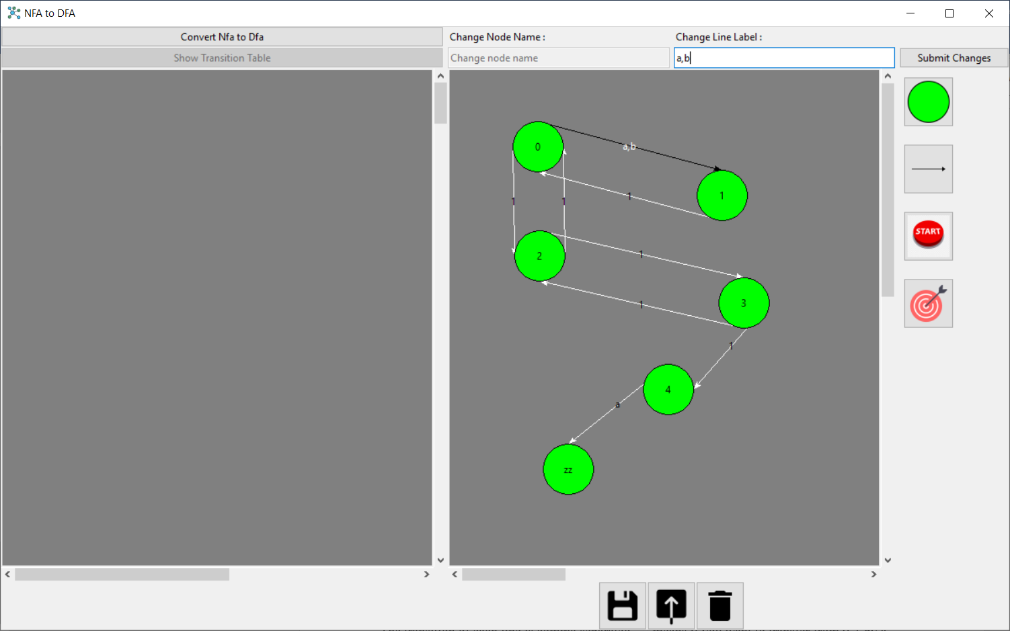

Figure 15 : Transition with multiple values

For epsilon transition if you want to add it between any two nodes select the line then left click on first node then right click on the other node this will add epsilon to the line if it’s already exists or add new line that has epsilon if doesn’t exists.

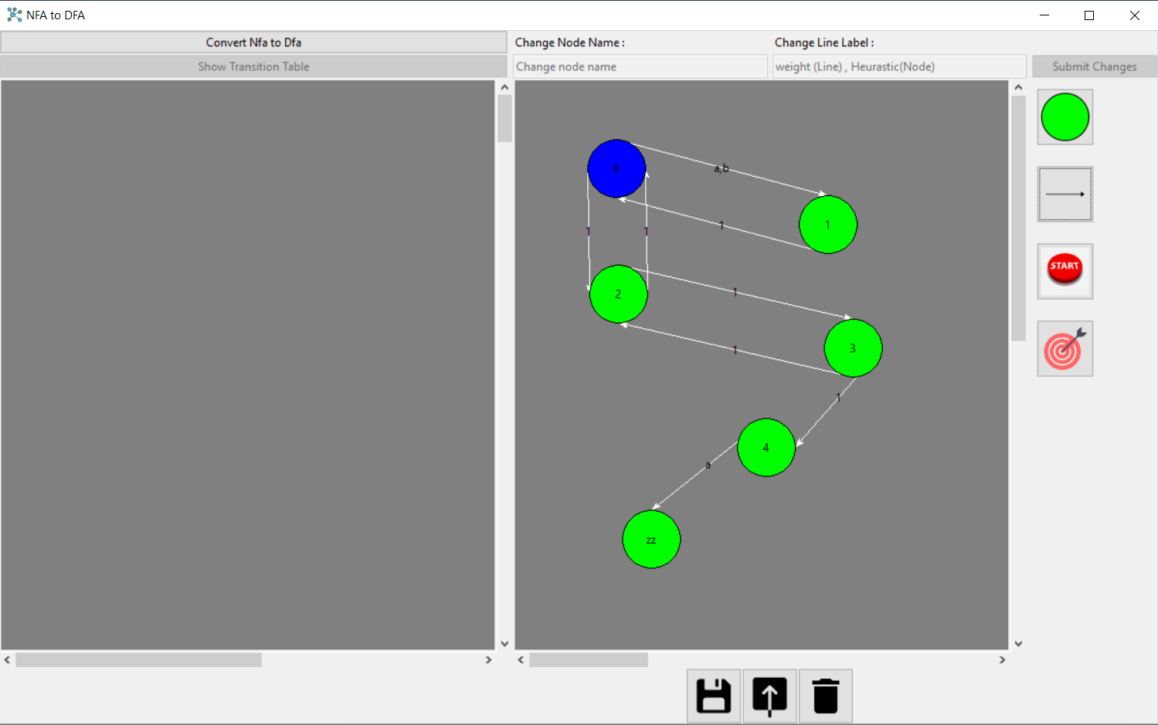

1. select line

2. left click on node

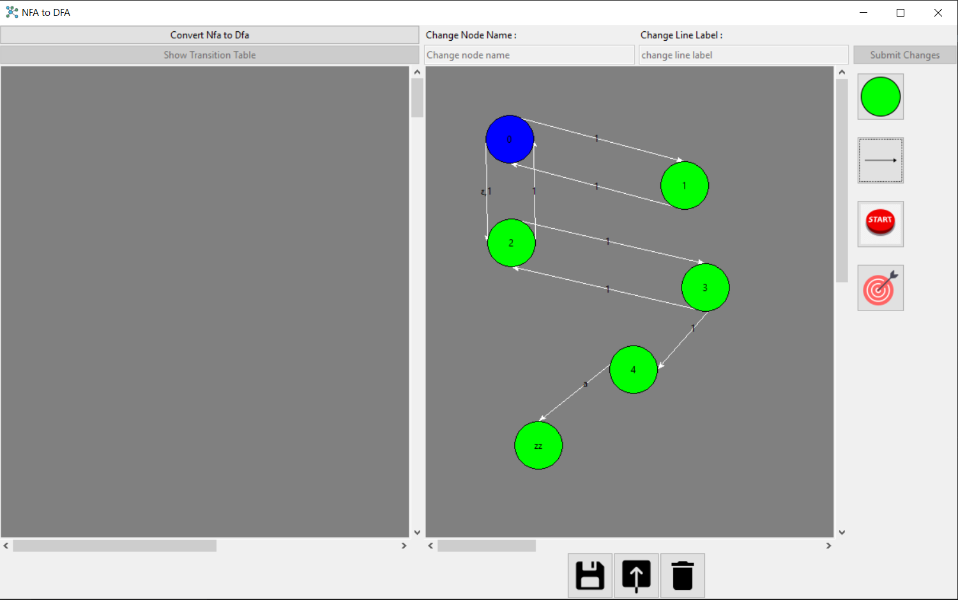

3. Right click on node

Figure 16 : adding epsilon connection

Connecting Node to itself by selecting the line then right click on the node.

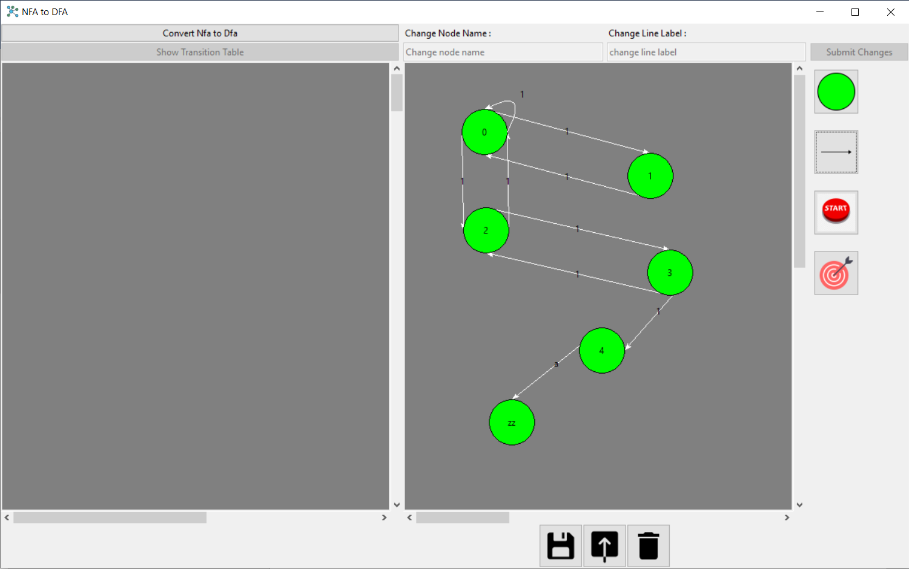

3. Right click on node

1. select line

Figure 17 : connecting node to itself

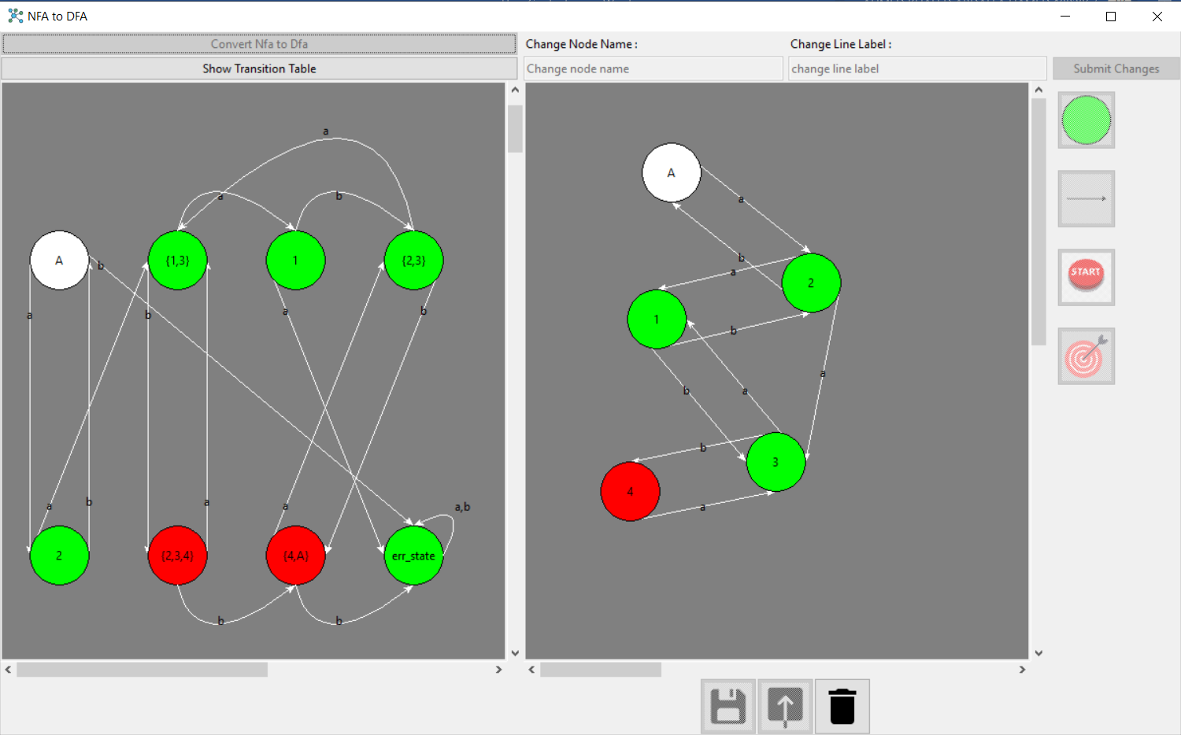Now after you learned how to create, edit and save your NFA , let’s click on convert Nfa to Dfa button and see what it does

Figure 18 : showing DFA

Converted DFA will be shown in the right canvas also you can click on show transition table to view the transition table

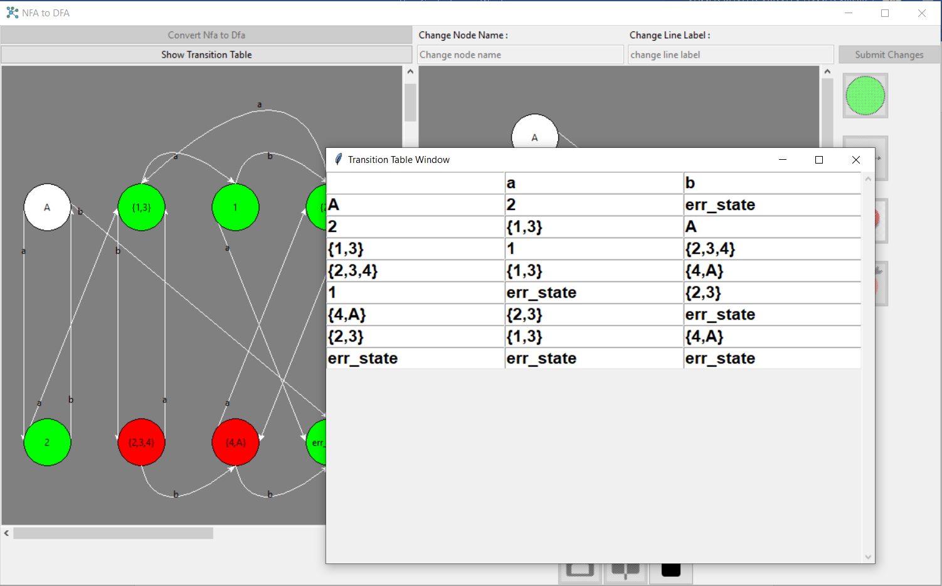

Figure 19 : showing transition table

If any edge isn’t clear in the drawn DFA you can click on it, its size will be bigger and clearer.

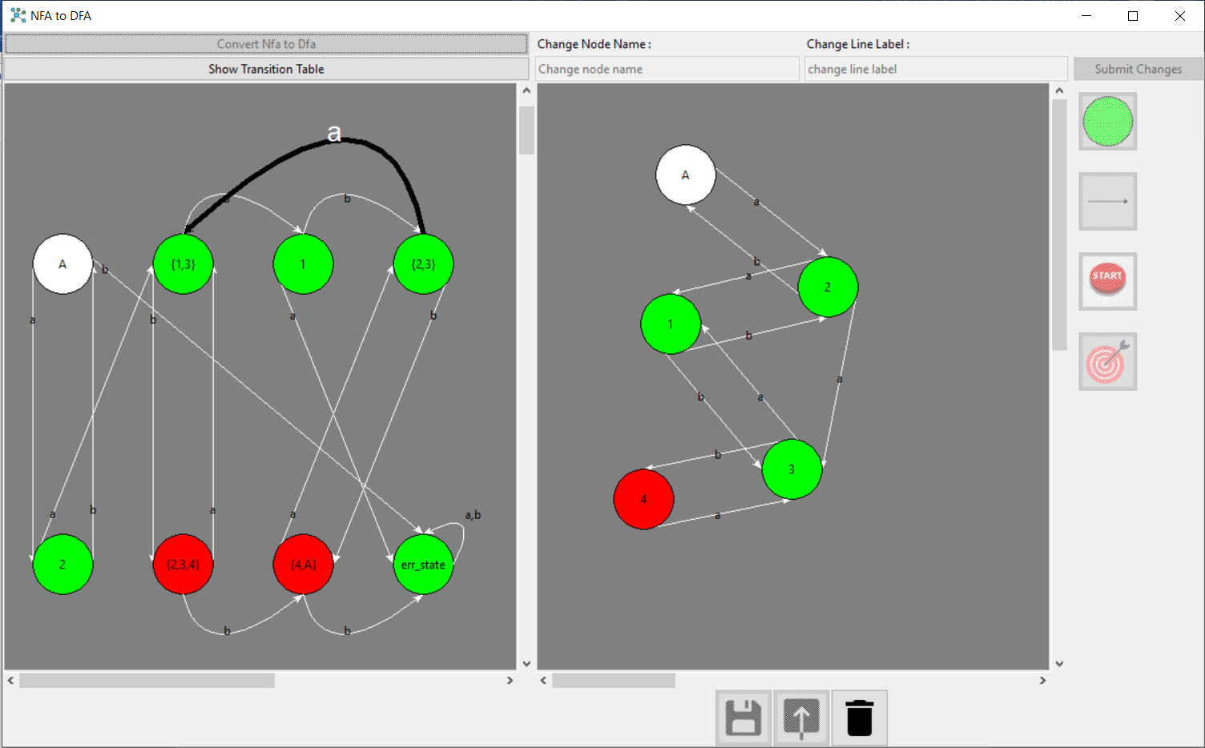

Figure 21 : selecting edge edge

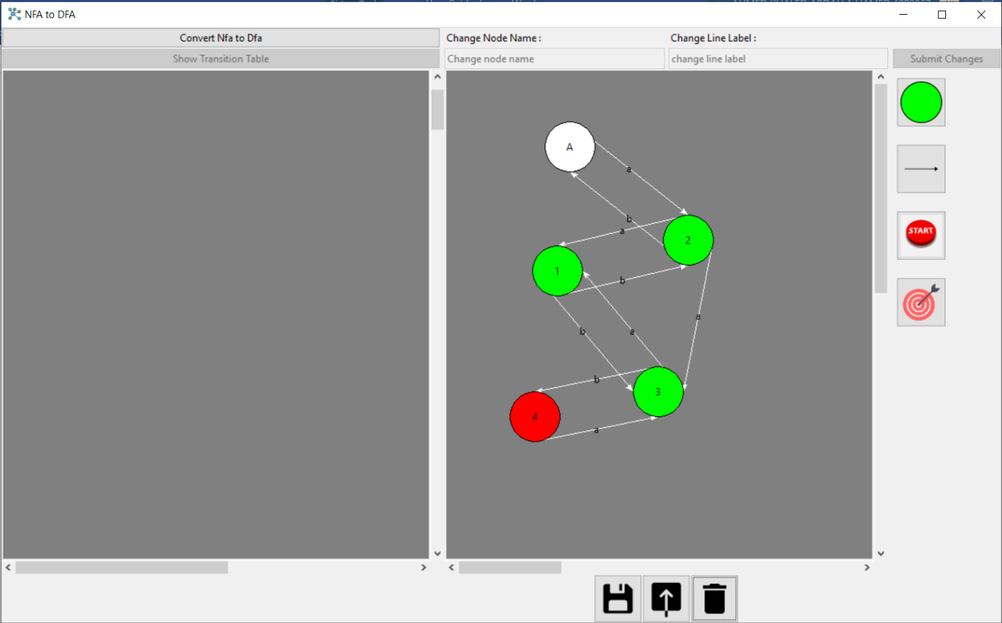To delete the drawn DFA.

Figure 21 : Deleting the DFA

*Colors of nodes in the application:*

White: start state

Red: final state